Web Portal Design
Version: | 0.1
Author(s): | Aleksandar Tolev
Created: | 04/27/2009
Last modification:

Version | Date | Author(s) | Changes
0.1 | 04/26/2009 | Aleksandar Tolev
Contents
1. Introduction 2
2. Design Patterns 2
2.1. Builder Pattern 2
2.1.1. UIBuilder 2
2.1.2. Concrete Builder 2
2.1.3. Director 3
2.1.4. Communication 3
2.2. Observer Pattern 4
2.3. Action Registry 5
2.4. Singleton pattern 5
3. Data Binding 6
4. Navigation 6
5. Portal view structure 6

Introduction
The following document describes the design of the web portal. In the “DecidR” application the web portal presents the user interface.
Some aspects of the design for example several design patterns, data binding and navigation and the user interface’s structure will be described.

Design Patterns

Builder Pattern

UIBuilder
The builder pattern abstracts the steps of the view’s construction depending on the user’s role. There is an interface describing a few methods for creating components. In our case these components are the header, the content, the navigation bar and the footer. Also it is possible to create a new view and to get the view.
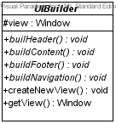

Concrete Builder
The concrete builder extends the ui builder and builds a specific view depending on the user’s role.
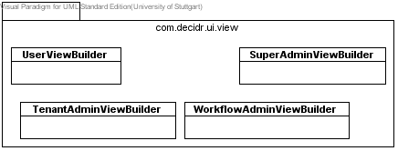

Director
The director manages the correct sequence for the view creation. It receives a concrete builder and executes the appropriate methods.

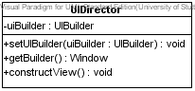

Communication
These entire separate components act together and finally a constructed view depending on the user’s role is the result. In the following picture the communication is shown.

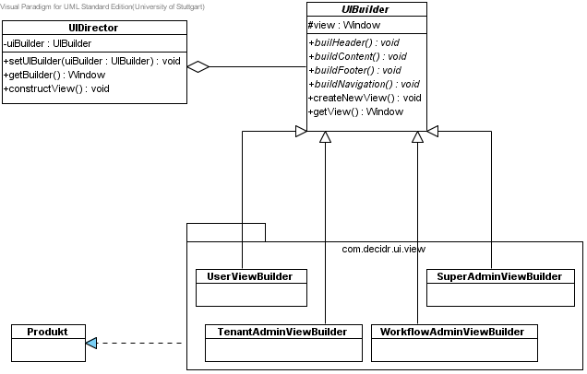

Observer Pattern
The observer pattern defines a one-to-many dependency between objects so that when one object changes state, all of its dependents are notified and updated automatically.
The observer pattern allows the view to change if the data has changed. The data which is changeable like users or workflow models extends the Observable class. The super class provides methods for adding, removing and notifying observer. If anything changes in these data classes the view will be notified about these changes and the update method from the Observer interface determines what to do. So that it works the view classes have to implement this interface.

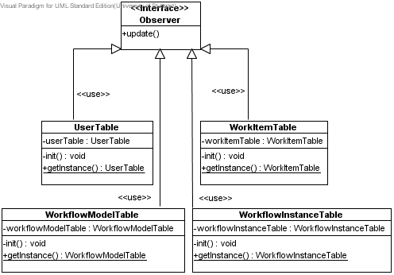

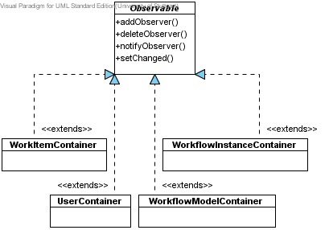

Action Registry
The registry isn’t a real pattern but it handles the action which will be used in the application. Every action is implemented in a separate class. The action registry offers methods for adding, removing and getting such action classes. All action classes are maintained over the action registry.
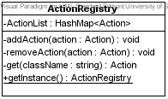

Singleton pattern
The singleton pattern ensures a class has only one instance, and provides a global point of access to it. Every view component implements the singleton pattern. The action registry implements the singleton pattern, too.

Data Binding
In the web portal there will be several tables, trees or anything else displaying information like workflow models, user list, workflow instances, work items and so on. To show these items on the web portal we decided to use containers in which we can store such information (properties). These properties are stored in Java Beans. These containers are connected with the corresponding components (table, trees, select). So the data is available through the containers where items can be extracted and placed in the view component to show the necessary information to the user. So the containers act as a controller in the web portal and delegate the information to the appropriate view components.
All these container classes extend the Observable class. By extending this class the containers are able to notify the corresponding view components if any data within the container has changed. For more information refer to Observer Pattern.

Navigation
The navigation in our “DecidR” application will not be a common page flow approach as it is usual for JSF or JSP applications. With the used ITMILL framework the navigation is handled like a normal desktop application. That means that there will be a swing-like approach. The flow is managed by action classes which are registered in the Action Registry.
The user can navigate through our application via a navigation bar displayed on the left side of the “DecidR” web portal.

Portal view structure
As mentioned in Builder Pattern the view is constructed depending on the user’s role. Every role has a specific view. In our case we have four roles: user, tenant admin, workflow admin and super admin. Starting from the user every following role has more privileges and therefore more components which are visible for the user with the concerning role.

